Motion Primitives

1: I trained the robot arm by using the record function in the library to get a test set of joint trajectories over a period of time. I then went into python and ran logistic regression on everything that looked sigmoid shaped over time with most of them having high R^2 value. In order to model the logit function, I just reversed the joint trajectories of the arm over time because Python did not like fitting a curve to my inverse function. Motor 5 and 6 had trajectories that were vaguely polynomial shaped and I was able to get an R^2 value of about .3 - .4, which seemed workable for the time being. After fitting the curves, I took the weights from the equation and transferred them over to C++ to act as the models of motion over time elapsed.

2: Motor 1 was a very small sigmoid function trajectory, The shape wasn't as well defined probably due to my shaky motions of dragging the arm out. The R^2 value for the model was .59.

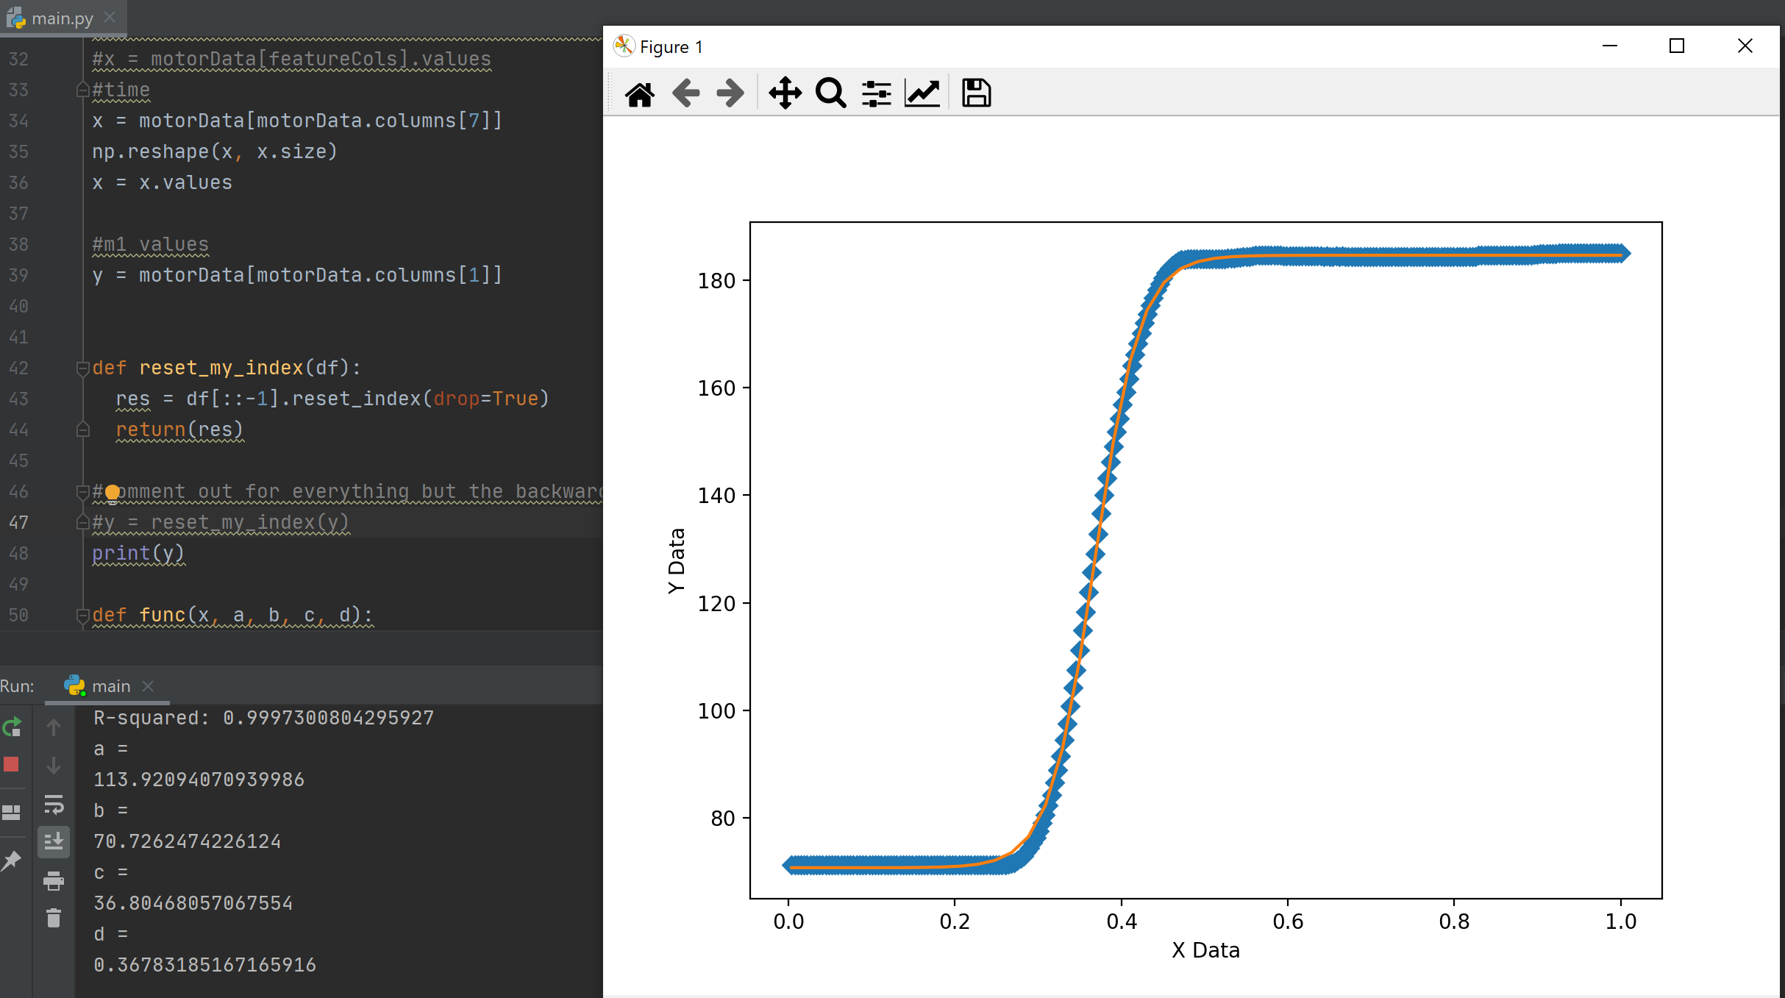
Motor 2 was sigmoid shaped and I was able to get an R^2 value of .9997 for the trained model.

Motor 4 was a logit function that I had to reverse the trajectory of in order to model. I was able to get an R^2 value of .999.

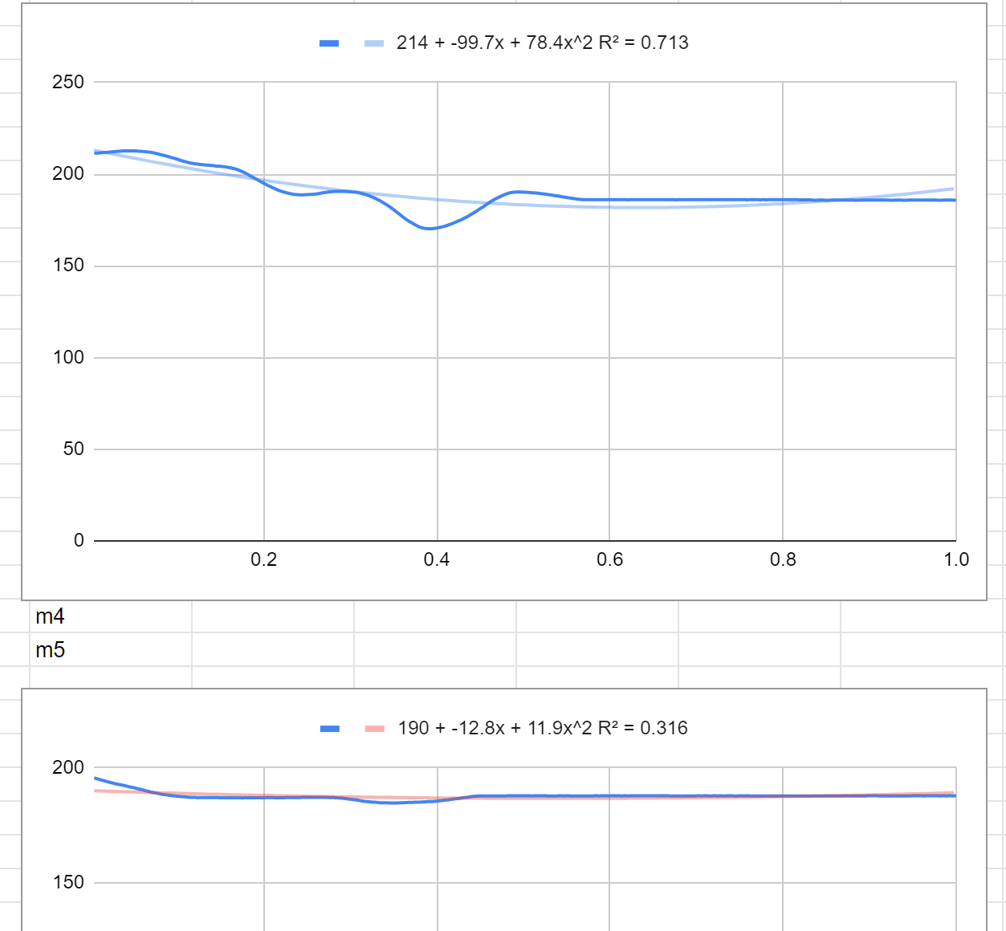

Motors 5(4) and 6(5) were more of a squiggly line most likely to my hand jiggling the motor around a little bit as I dragged the arm up. Motor 4 had an R^2 value of .713 and Motor 5 had an R^2 value of .316

Motor 7 does not move for this motion, so it was omitted from modeling.

I used R^2 values to judge how close the model was to matching the training set of data recorded from my motions. Overall, most of the motors were a decent fit for the data as I think it smoothed out some of the wobbliness of my motions in the recording set. I do think Motor 5 is the least accurate because it was being directly moved by my hand and was thus most subject to any minor inconsistencies in motion. Motor 2 and 3 were the most accurate due to them being dragged by the rest of the arm and their motion trajectories were limited to the construction of the arm.

